ANOVA Project
mETRO sTATE stat 301-01
Michael Salthar, Charles sANDAHL
2026
Introduction
We set out to research teenage mental health. We found a dataset on Kaggle called “Social Media Impact on Teen Mental Health”, which included columns for many different variables including numerical ones such as sleep hours and academic performance and categorical ones such as the gender, platform usage, and social interaction. Our research question is how does stress and anxiety affect academic performance? The stress and anxiety levels are taken on a scale from 1-10, and academic performance is grade point average. Our hypotheses are as follows:
Testing academic performance between stress level groups:
$$H_{0}: μ_{stressHigh} = μ_{stressLow}$$
$$H_{a}:μ_{stressHigh}≠μ_{streeLow}$$
Testing academic performance between anxiety level groups:
$$H_{o}:μ_{anxietyHigh}=μ_{anxietyLow}$$
$$H_{a}: μ_{anxietyHigh}≠μ_{anxietyLow}$$
Testing whether or not stress and anxiety levels groups interact:
$$H_{0}:There is no interaction between Anxiety and Stress$$
$$H_{a}:There is an interaction between Anxiety and Stress$$
Methods
We chose to use a two-way unbalanced ANOVA method in our analysis, given the unbalanced distribution between the categorical variables in our study. Two-way ANOVA was chosen to test the main effects of academic performance between stress levels in teenagers, and the main effects of academic performance between anxiety levels in teenagers, and their interaction.
We chose a two-way unbalanced ANOVA test for this research question because we effectively want to know if there is a significant difference in academic performance between low and high stress level groups, and likewise for anxiety level groups. Using a two-way ANOVA test also allows for testing of an interaction between stress level and anxiety level groups. We chose an unbalanced test because the number of individuals in each group was unequal.
The dataset was devoid of missing values when we downloaded it initially from Kaggle, but we had to change a couple of variables that were formatted as numeric but functionally categorical into categorical variables with pronounced levels. These variables were originally formatted as a score between 1 to 10, so effectively are ordinal in nature, and we reformatted these variables into two levels: “low” and “high,” using a score of 5 as the cutoff point between the two levels. We then used the two converted categorical variables (stress levels, anxiety levels) as the main independent variables in our two-way unbalanced ANOVA analysis.
Conclusion
 | F-value | P-value
Anxiety | 2.5472 | 0.1108
Stress | 0.3848 | 0.5352
Anxiety*Stress | 0.5712 | 0.4499

Regarding academic performance between anxiety levels, with a p-value of 0.1108, since the p-value is greater than $α=0.05$, we fail to reject $H_{o}$. We cannot conclude that there is a significant difference in academic performance between anxiety levels in teenagers in this dataset. However, with a low p-value, more research may need to be conducted to decisively conclude whether academic performance is different between anxiety levels.
Regarding academic performance between stress levels, with a p-value 0.5352, since the p-value greater than $α=0.05$, we fail to reject $H_{o}$, We cannot conclude that there is a significant difference in academic performance between stress levels in teenagers in this dataset.

Regarding academic performance in the interaction between anxiety levels and stress levels, with a p-value of 0.4499, since the p-value is greater than $α=0.05,$ we fail to reject $H_{o}$. We cannot conclude that there is an interaction between anxiety levels and stress levels.
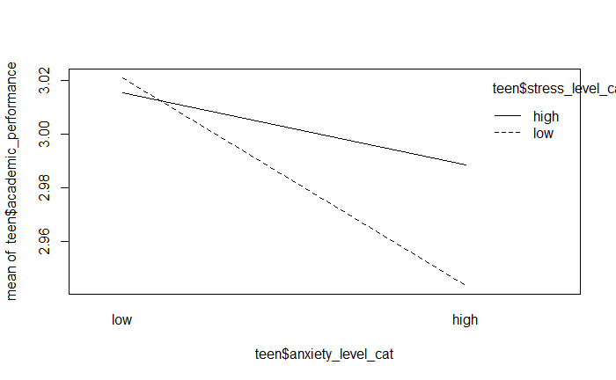
The interaction plot shows what could be an interaction between both independent variables, but this could be explained by the very small scale of the interaction plot (GPA 3.02-2.96). Due to the high p-value of the interaction of about 0.45, we still must conclude that there is no interaction.
Considering the results of testing, we cannot conclude at all that academic performance is any different between teenagers with high or low anxiety levels, and similarly for individuals with high or low stress levels.
This is surprising to our team, given our pre-conceived assumptions that mental health levels within teenagers would make a difference in academic performance. Pre-study, we were confident that mental health would directly affect various metrics within teenagers, including academic performance. It appears, given the data, that these pre-conceived assumptions were ignorant.
However, these results may not be conclusive in the question of whether or not academic performance is different between stress and anxiety levels within teenage demographics for the following reasons: the dataset provided by Kaggle may have been a “synthetic” dataset and not labeled as such on the website, meaning the data may have been completely simulated and not represent real-world values. This would call into question the validity of the data, and certainly affect analyses conducted under the pretense that this dataset indeed represents real-world data. Also, underlying factors may have been excluded from the dataset, such as the socioeconomic status of the parents of the teenagers in the data, or any other relevant variable presumably related to mental health. Ultimately, more testing would need to be done before any conclusions can be made about anxiety and stress levels in teenagers, and their respective effects on academic performance.

